Ansible Task -02

Watch ansible-02 video and write down notes.
Task Title
Install Apache (httpd) using Ansible Playbook with Handlers and Notifiers
Objective
To install and configure the Apache web server on Ubuntu servers using an Ansible playbook, deploy an index.html file, and restart the Apache service automatically using handlers and notify.
Prerequisites
- Ubuntu server(s)
- Ansible installed on control node
- SSH access to managed nodes
- Inventory file configured
- Root or sudo access
- Basic knowledge of Ansible playbooks
Step-by-Step Implementation:
Step 1: Create Playbooks Directory
- Created a directory named playbooks
- Navigated into the directory
Command executed:
mkdir playbooks
cd playbooks
Step 2: Verify Directory Structure
- Verified the directory was created successfully using ll
Command executed:
ll
Step 3: Create Ansible Playbook
- Created apache.yml using vi
- Defined hosts, become, tasks, handlers, and notify
Playbook content:
---
- hosts: all
become: yes

tasks:
- name: Install Apache
apt:
name: apache2
state: latest

- name: Copy index.html
copy:
src: index.html
dest: /var/www/html/index.html
notify: restart apache2

handlers:
- name: restart apache2
service:
name: apache2
state: restarted
Step 4: Create index.html File
- Created a simple HTML file which will be deployed to Apache web root and inserted an sample script
Step 5: Execute Ansible Playbook
- Ran the playbook using ansible-playbook
- Apache installed successfully
- index.html copied
- Handler triggered to restart Apache
Command executed:
ansible-playbook apache.yml
Result:
- Tasks executed successfully
- Handler restart apache2 triggered due to file change
- No failures reported
Step 6: Verify Apache Web Page
- Accessed Apache server from browser using public IP
- Verified deployed e-commerce sample page loads successfully
URL accessed:
http://<EC2-PUBLIC-IP>
Validation Steps
- Apache service installed and running
- index.html successfully deployed to /var/www/html
- Web page accessible via browser
- Handler triggered only when file changed
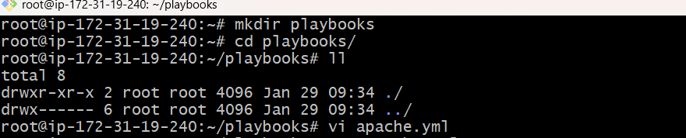
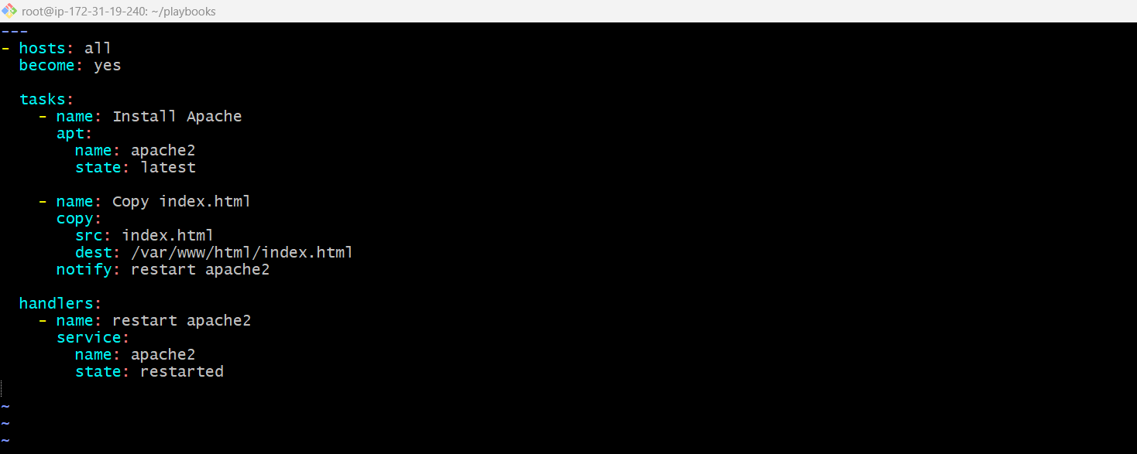

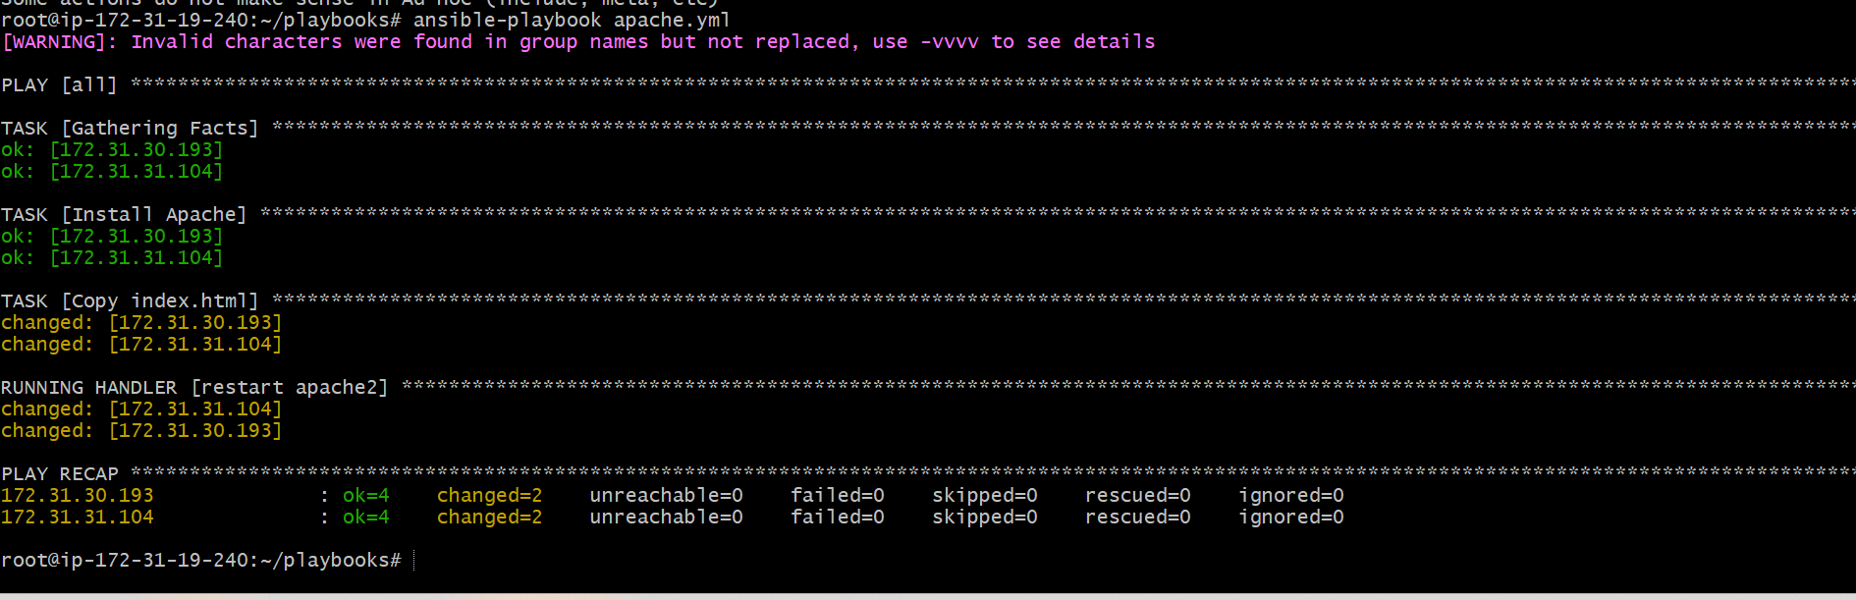
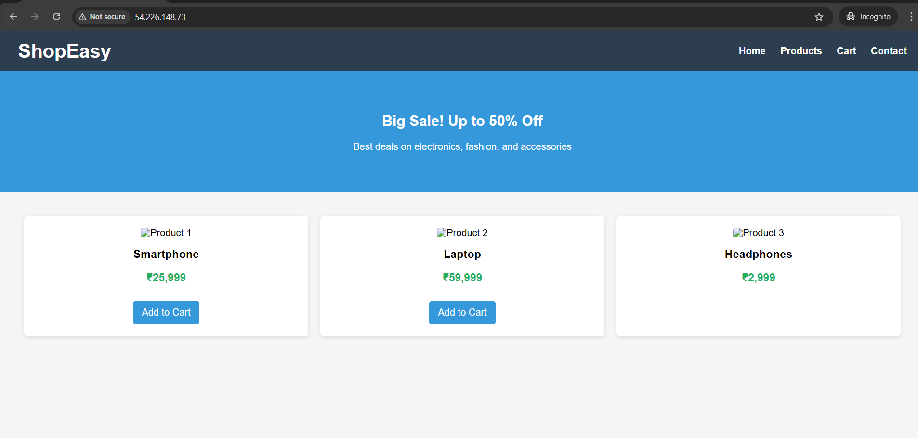
Issues Faced
- Warning related to invalid characters in group names (non-blocking)
- Resolved by ensuring inventory group names follow Ansible naming standards
Conclusion
Apache was successfully installed and configured using an Ansible playbook.
The notify and handlers mechanism ensured Apache restarted only when required, following Ansible best practices.
The web application was verified successfully through browser access.

Task Title
Install Apache Tomcat using Ansible Playbook
Objective
To automate the installation of Apache Tomcat on Ubuntu servers using an Ansible playbook by installing Java, downloading Tomcat, extracting it, and starting the Tomcat service successfully.
Prerequisites
- Ubuntu server(s)
- Ansible installed on control node
- SSH connectivity between control node and managed nodes
- Sudo/root privileges
- Inventory file configured correctly
Step-by-Step Implementation:
Step 1: Create Playbooks Directory
- Created a directory named playbooks on the Ansible control node.
- Navigated into the directory to store Ansible playbooks.
Commands executed:
mkdir playbooks
cd playbooks
Step 2: Create Ansible Playbook File
- Created a new Ansible playbook file named apache_tomcat.yml using the vi editor.
Command executed:
vi apache_tomcat.yml
Step 3: Write Apache Tomcat Playbook
- Defined the target hosts and enabled privilege escalation.
- Added tasks to:
  - Install Java (OpenJDK)
  - Download Apache Tomcat
  - Create Tomcat installation directory
  - Extract Tomcat archive
  - Start Tomcat with JAVA_HOME configured
Playbook content:
---
- hosts: all
become: yes
tasks:
- name: Install Java
apt:
name: openjdk-11-jdk
state: present
update_cache: yes
- name: Download Tomcat
get_url:
url: https://archive.apache.org/dist/tomcat/tomcat-9/v9.0.85/bin/apache-tomcat-9.0.85.tar.gz
dest: /tmp/tomcat.tar.gz
- name: Create Tomcat directory
file:
path: /opt/tomcat
state: directory
- name: Extract Tomcat
unarchive:
src: /tmp/tomcat.tar.gz
dest: /opt/tomcat
remote_src: yes
extra_opts: [--strip-components=1]
- name: Start Tomcat
shell: |
export JAVA_HOME=/usr/lib/jvm/java-11-openjdk-amd64
nohup /opt/tomcat/bin/catalina.sh run > /opt/tomcat/logs/catalina.out 2>&1 &
Step 4: Execute the Ansible Playbook
- Executed the Ansible playbook to install and start Apache Tomcat on the target servers.
- All tasks completed successfully without errors.
Command executed:
ansible-playbook apache_tomcat.yml
Step 5: Verify Tomcat Installation
- Navigated to the Tomcat installation directory.
- Verified that Tomcat binaries were present.
Commands executed:
cd /opt/tomcat/bin
ls
Step 6: Verify Tomcat Process
- Checked running processes to confirm that Tomcat was running successfully.
Command executed:
ps -ef | grep tomcat
Step 7: Verify Tomcat in Browser
- Accessed the Tomcat application using a web browser.
- Confirmed successful installation by viewing the Tomcat default page.
URL accessed:
http://<SERVER-PUBLIC-IP>:8080
Validation Steps
- Java installed successfully
- Tomcat downloaded and extracted
- Tomcat process running
- Tomcat web interface accessible
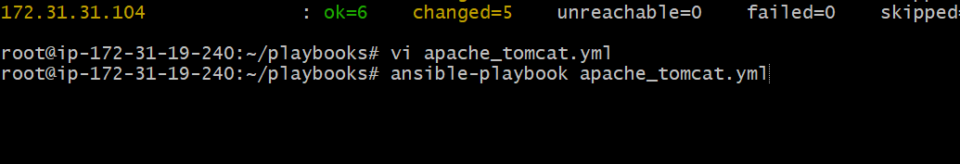
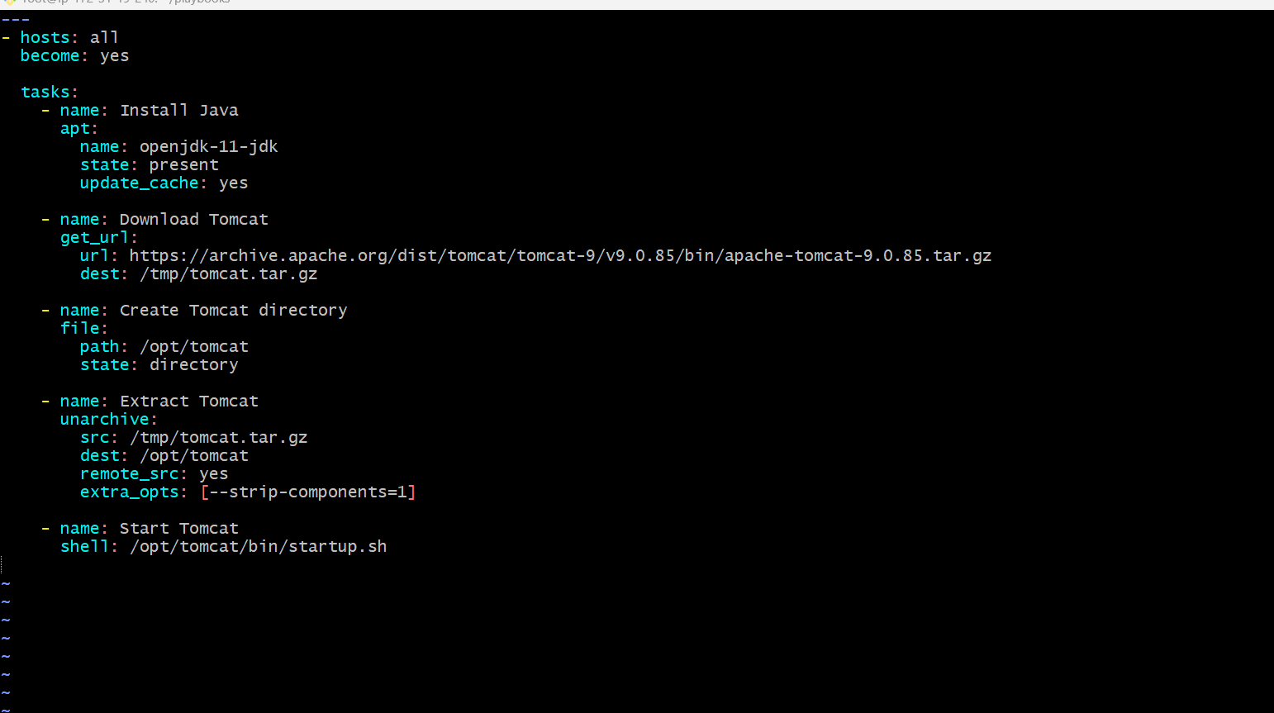
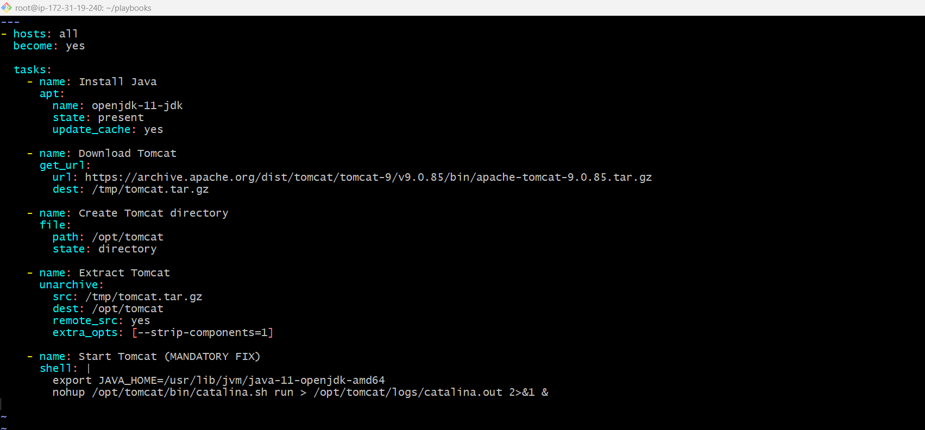
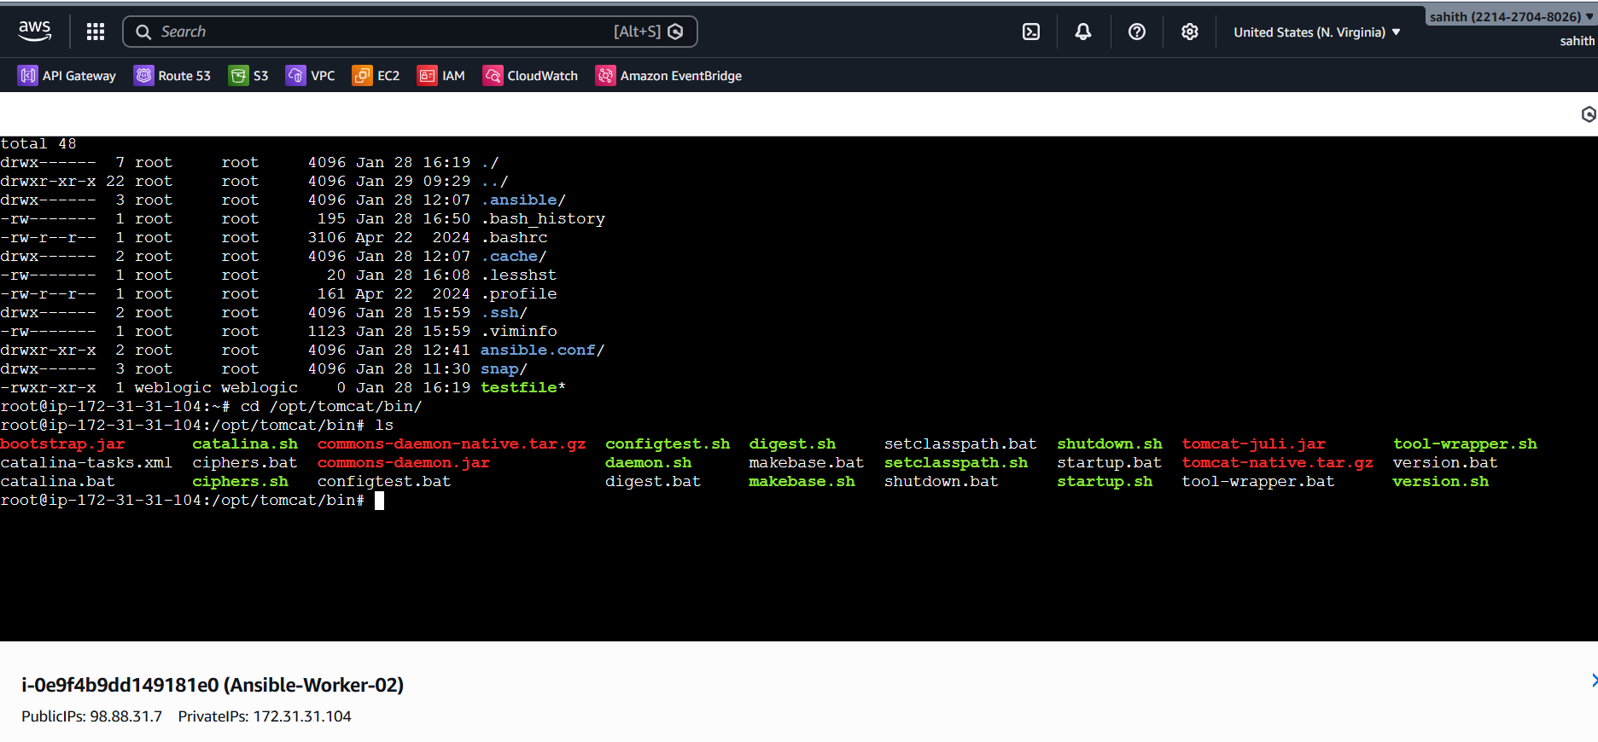
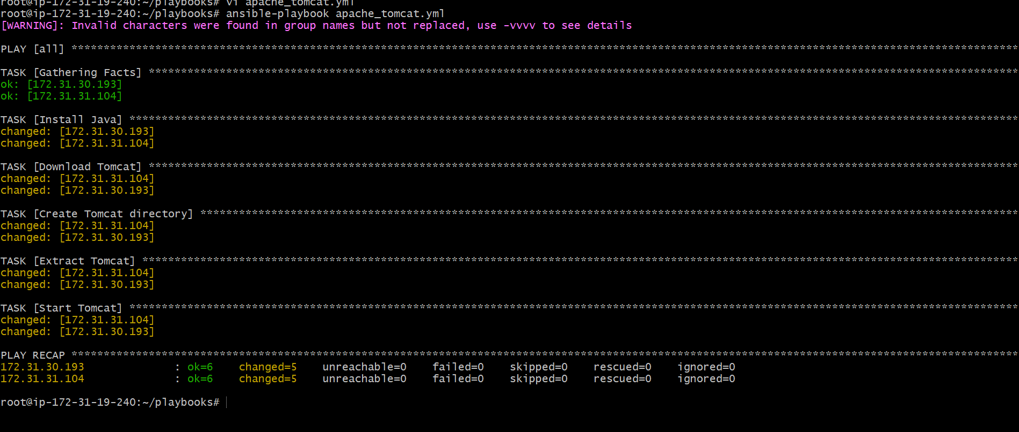
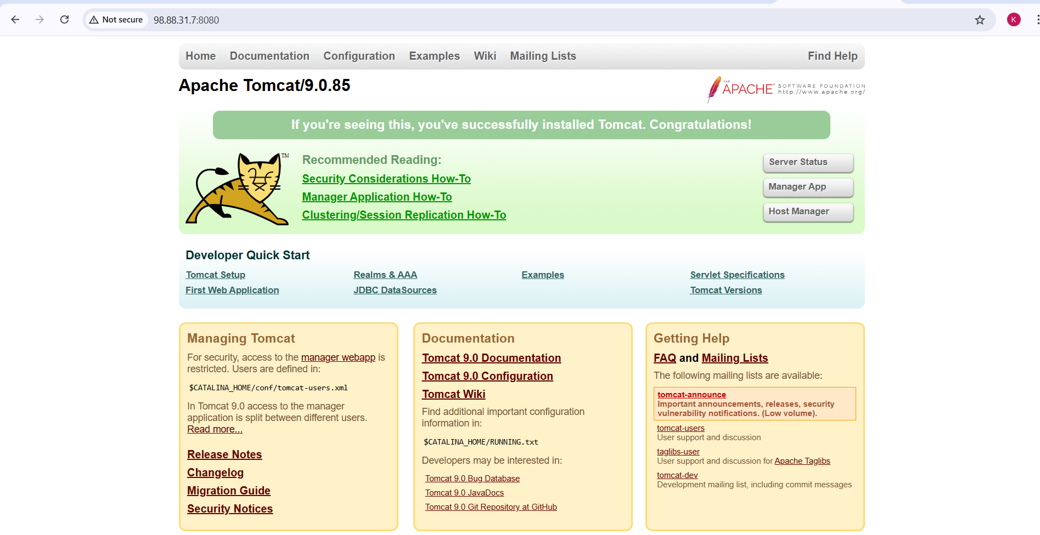
Issues Faced:
- Tomcat did not start initially because JAVA_HOME was not set.
- Issue resolved by exporting JAVA_HOME before starting Tomcat.
Conclusion:
Apache Tomcat was successfully installed and started using an Ansible playbook.
The automation ensured consistent deployment across servers and verified successful access through the browser.

Task Title
Provision One EC2 Instance on AWS Using Ansible Playbooks
Objective
To automate the provisioning of a single Amazon EC2 instance using an Ansible playbook by configuring AWS CLI, setting up required dependencies, and executing the EC2 creation task.
Prerequisites
- AWS account
- IAM user with EC2 permissions
- AWS Access Key and Secret Key
- Ansible installed on control node
- Python installed
- Internet access from control node
Steps Performed:
Step 1: Update System Packages
- Updated the package repository to ensure latest package information.
apt update
Step 2: Install Required Utilities
- Installed required utilities such as unzip and curl.
apt install unzip curl -y
Step 3: Install AWS CLI
- Downloaded AWS CLI v2 zip package.
- Extracted and installed AWS CLI.
unzip awscliv2.zip
./aws/install
- Verified AWS CLI installation.
aws --version
Step 4: Configure AWS Credentials
- Configured AWS credentials using access key and secret key.
- Set default region and output format.
aws configure
Step 5: Create Ansible Playbook for EC2
- Created a playbook file named aws_ec2.yml.
- Defined localhost as execution host since AWS resources are created via API.
- Used amazon.aws.ec2_instance module to provision EC2.
---
- hosts: localhost
connection: local
gather_facts: no

tasks:
- name: Create EC2 instance
amazon.aws.ec2_instance:
name: Ansible_Task_02
region: us-east-1
instance_type: t3.micro
image_id: ami-0b6c6ebed2801a5cb
key_name: NV
security_group: default
wait: yes
Step 6: Execute the Ansible Playbook
- Ran the playbook using Ansible.
- Verified that the task executed successfully without errors.
ansible-playbook aws_ec2.yml
Step 7: Validate EC2 Instance Creation
- Logged into AWS Management Console.
- Navigated to EC2 → Instances.
- Verified the EC2 instance named Ansible_Task_02 was created and running.
Validation Steps
- AWS CLI installed and configured successfully
- Ansible playbook executed without failures
- EC2 instance visible in AWS Console
- Instance state shown as Running

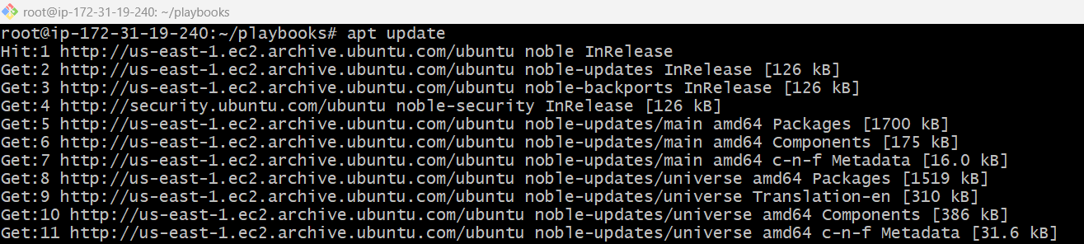
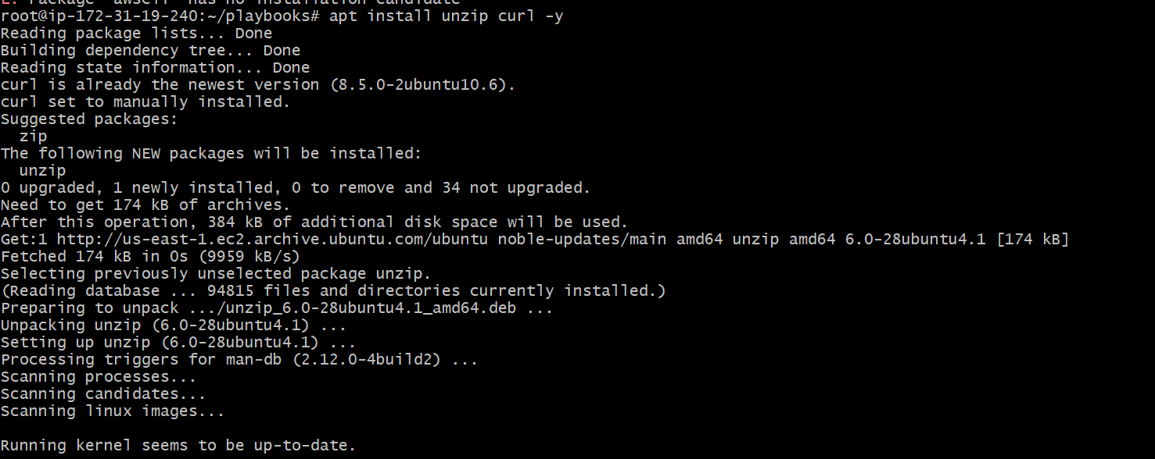
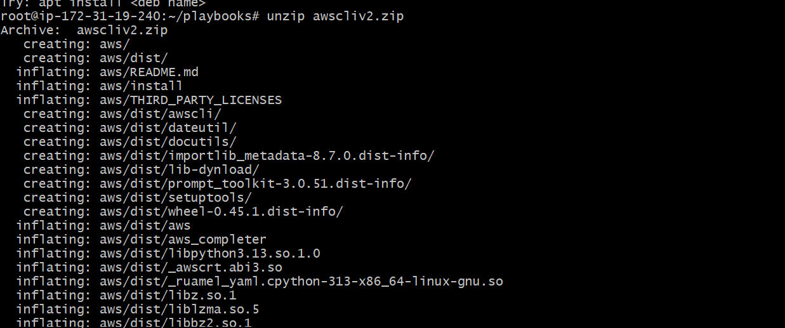
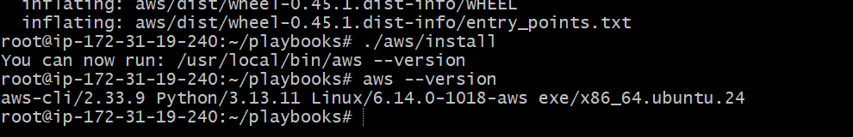

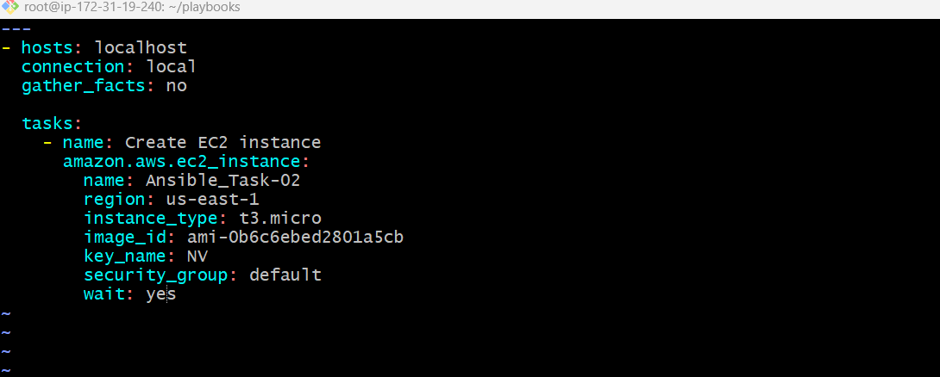
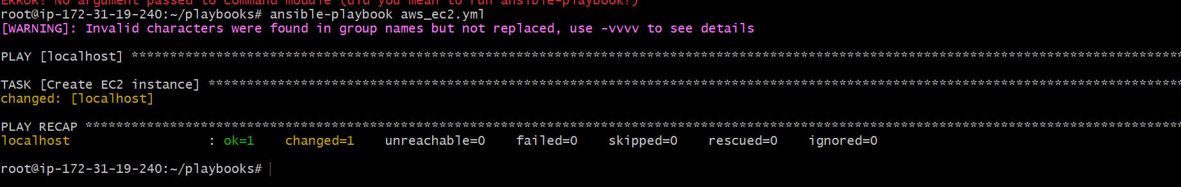
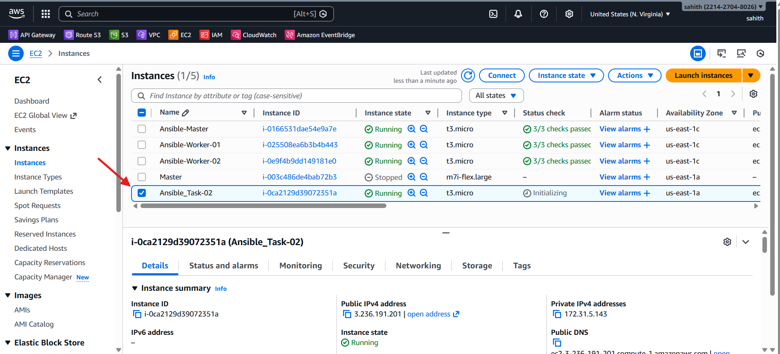

Issues Faced:
- AWS CLI was initially not installed
- Resolved by installing AWS CLI v2 and configuring credentials
Conclusion:
The Ansible playbook successfully provisioned one EC2 instance on AWS.
This automation ensures consistent, repeatable, and efficient infrastructure provisioning using Ansible and AWS APIs.

Task Title
Copy one File from Node-1 to Node-2 Using Ansible playbook
Objective
To copy a file from node-1 (worker-01) to node-2 (worker-02) using an Ansible playbook by fetching the file to the control node and then copying it to the destination node.
Prerequisites
- Ansible installed on control node
- SSH connectivity between control node and worker nodes
- Inventory file configured with worker-01 and worker-02
- Root or sudo access on all nodes
- Source file available on node-1
Steps Performed:
Step 1: Verify Source File on Node-1
- Logged into worker-01.
- Verified that the file exists in /tmp.
ls /tmp/sample.txt
Step 2: Create Ansible Playbook
- Created a playbook file named copy_node1_to_node2.yml.
- Defined two plays:
  - First play to fetch the file from node-1 to the control node
  - Second play to copy the file from control node to node-2
---
- name: Copy file from node-1 to node-2
hosts: worker-01
become: yes
tasks:
- name: Fetch file from worker-01 to control node
fetch:
src: /tmp/sample.txt
dest: /tmp/sample.txt
flat: yes
- name: Copy file from control node to worker-02
hosts: worker-02
become: yes
tasks:
- name: Copy file to worker-02
copy:
src: /tmp/sample.txt
dest: /tmp/sample.txt
Step 3: Execute the Ansible Playbook
- Ran the playbook from the control node.
- The file was successfully fetched from node-1 and copied to node-2.
ansible-playbook copy_node1_to_node2.yml
Step 4: Verify File on Node-2
- Logged into worker-02.
- Verified that the file exists in /tmp.
ls /tmp/sample.txt
Validation Steps
- File exists on node-1 before execution
- Playbook executed without errors
- File successfully copied to node-2
- File content remains unchanged
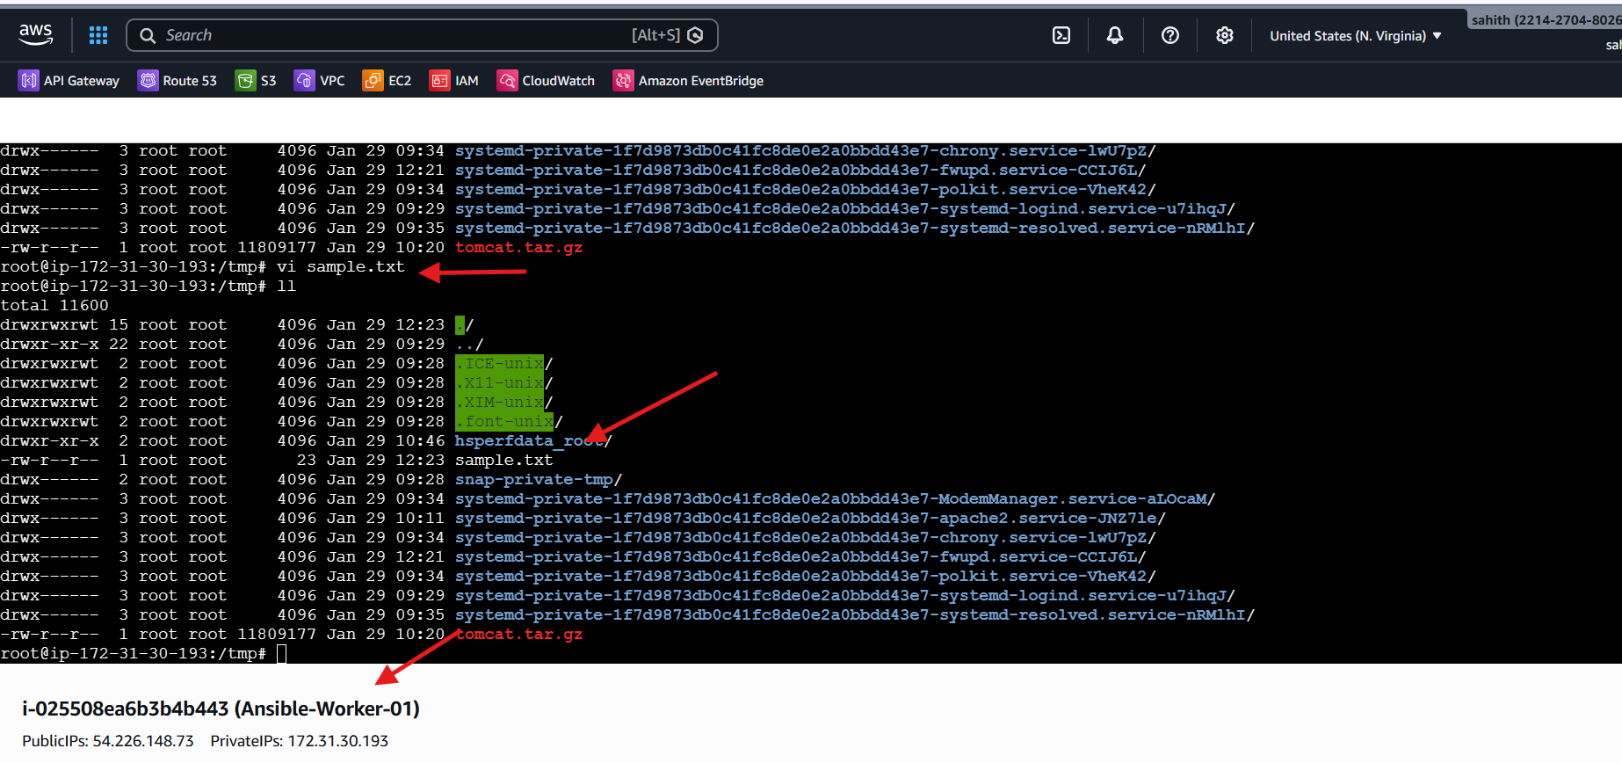
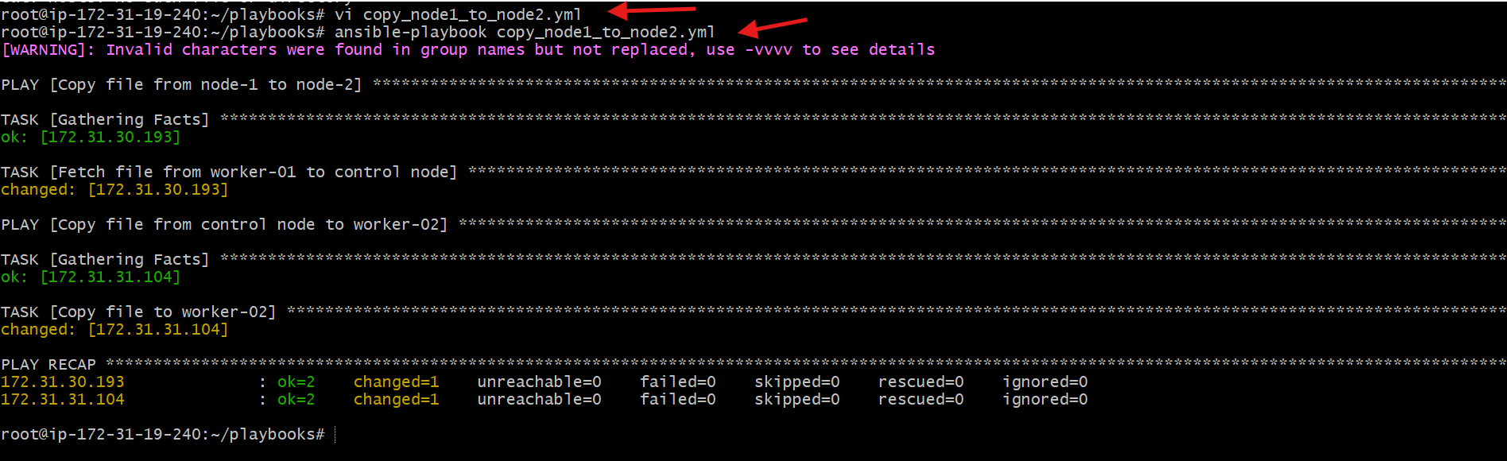
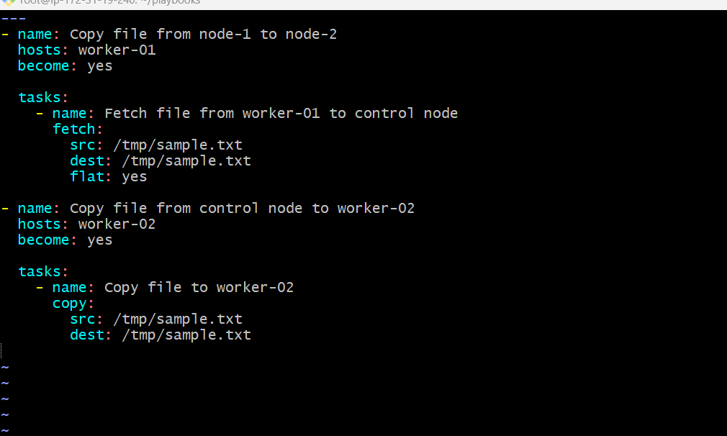
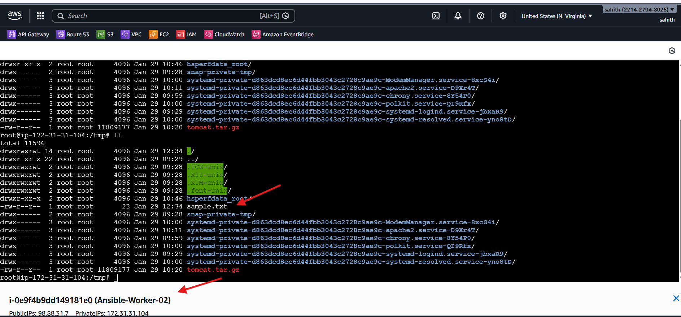

Issues Faced:
- Host pattern mismatch warnings occurred initially
- Issue resolved by ensuring worker-01 and worker-02 were correctly defined in the inventory file
Conclusion:
The Ansible playbook successfully copied a file from node-1 to node-2.
This demonstrates how Ansible transfers files between nodes using the control node as an intermediary.

Task Title
Create Multiple Files with Different Names Using a Single Ansible Playbook.
Objective
To create multiple files with different names on managed nodes using a single Ansible playbook by leveraging looping functionality.
Prerequisites
- Ansible installed on control node
- SSH connectivity to managed nodes
- Inventory file configured correctly
- Root or sudo privileges on target nodes
Steps Performed:
Step 1: Create Ansible Playbook File
- Created a playbook file named create_multiple_files.yml inside the playbooks directory.
vi create_multiple_files.yml
Step 2: Write the Playbook to Create Multiple Files
- Defined target hosts and enabled privilege escalation.
- Used the file module with a loop to create multiple files with different names in /tmp.
---
- name: Create multiple files using single playbook
hosts: all
become: yes

tasks:
- name: Create different files
file:
path: "/tmp/{{ item }}"
state: touch
loop:
- chan.txt
- hello.txt
- test.txt
- task.txt
Step 3: Execute the Ansible Playbook
- Ran the playbook using the Ansible command.
- The playbook executed successfully on all target nodes.
ansible-playbook create_multiple_files.yml
Step 4: Verify File Creation on Target Nodes
- Logged into each managed node.
- Verified that all specified files were created successfully in the /tmp directory.
ls /tmp
Validation Steps
- Playbook executed without errors
- All specified files were created on target nodes
- File names matched the loop entries
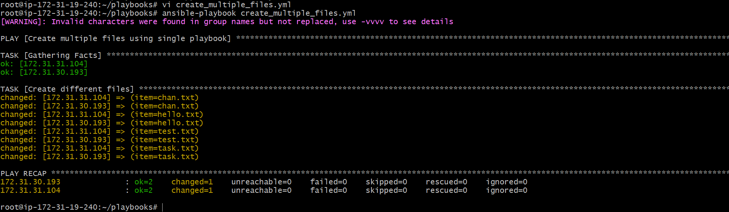
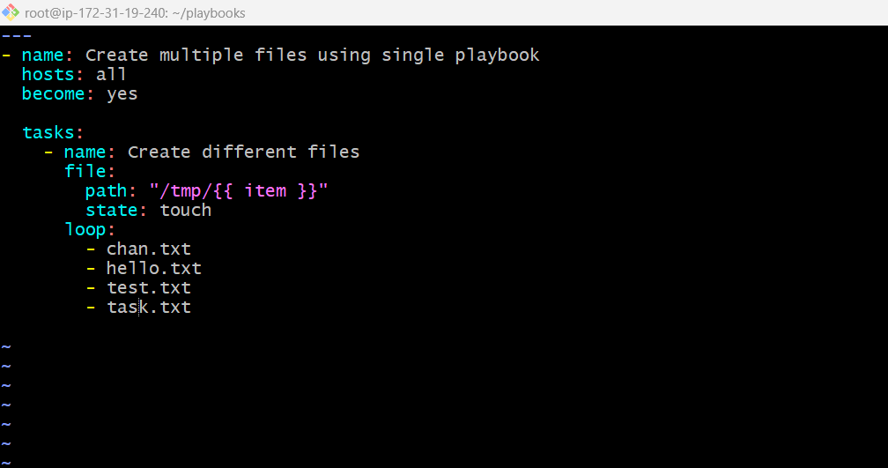
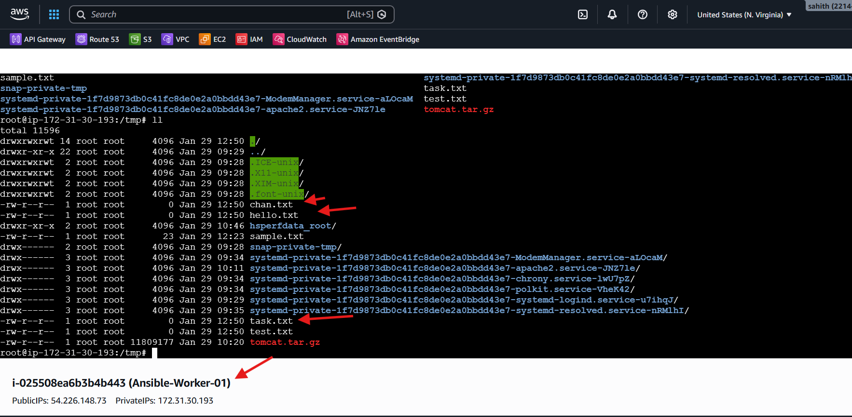
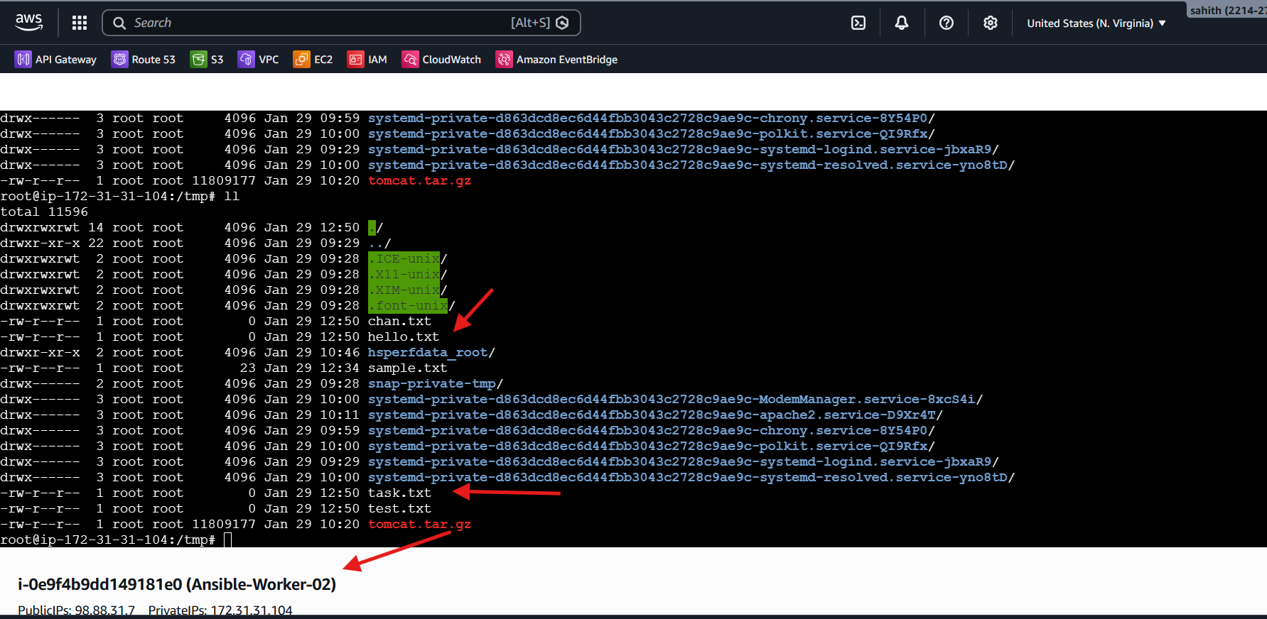

Issues Faced
- Warning about invalid characters in group names appeared
- Warning did not affect playbook execution
Conclusion
Using a single Ansible playbook and loop functionality, multiple files with different names were successfully created across managed nodes. This approach reduces repetition and improves automation efficiency.

